INDEX

|  |  |  |
| --- | --- | --- |
| **Sr.no** | **Topic** | **Page no** |
|  | Aim | 1 |
|  | Objectives and Scope of the Project | 2 |
|  | System Requirements | 3 |
|  | Salient Features | 4 |
|  | A Walk Through | 5 |
|  | Bibliography | 37 |

AIM

The Aim of the project is the allow the user to download You-Tube Videos with ease. The Project must also be able to satisfy the following objectives :

1. The User should be able to download You-Tube Videos in *1080p and 720p,* depending on the upload resolution of the video.
2. The User should be able to download the same video in a *lower* *resolution* of *360p*, or *480p* as well.
3. The User should also be able to download *only the sound* of the video, as well as only the Video in it’s *Highest* *Resolution*.
4. The User should be able to *Change the path of the downloaded video* in the computer within the software using a File selection Dialog Box
5. The User must be able to view the *progress* of the video downloaded, both as a *Progress Bar*, and also in *Percentages*.
6. The Software should show an *Estimated* *File* *Size* for each resolution of the video downloaded.
7. The User Must also be able to download *entire You-Tube playlists*, deselect, *Select,* and *remove* certain videos from the playlist, and must be able to see the *count* of the *videos* *Downloaded* and *Remaining*.
8. The User Must be able to view *Graphs*, and *Statistics* regarding the Videos that have been downloaded by the software.
9. The Data of all the downloaded videos must be saved as a *‘.csv’* file, and processed by *Pandas* in the form of a *DataFrame*.

OBJECTIVE AND SCOPE OF THE PROJECT

* Scope of the Project :

1. Download Quality :
2. 1080p
3. 720p
4. 480p
5. 2160p
6. 120 Hz audio
7. Download Format :
8. .mp4
9. .webm
10. .ogg
11. .wav

* Limitations of the Project

1. Can only download video and linked audio up to 720p
2. Some Playlist links are not supported, ones that are updated by youtube and protected under copyright laws.
3. Only a maximum of 100 videos can be download at once.
4. Requires constant maintenance, and version updates.
5. Heavy Reliability on foreign Dependencies and modules.
6. Does not support multiple downloads at once.
7. Graphs do not get updated immediately after updating the csv file.
8. Cannot Resume downloading videos from the point of interruption.

SYSTEM REQUIREMENTS

* Dependencies and System Requirements :

1. *Active Connection* to internet *while running* the program
2. Minimum of a *x64* or *x86* computer
3. *100* *MB* *RAM*, *200* *MB* Free Storage Space
4. Monitor Resolution – *1280* x *720p*
5. *Windows 7, 8, or 10.*

* Compilation of Source Code

1. *Python 3.7 to 3.9* as of date of writing.
2. Modules *pytube* 10.0, *pillow*, *requests*, *pandas*, *matplotlib*, *youtube*-*dl*
3. Run the following Commands in the *command prompt* of an *activated* virtual environment of the suggested python version, or the via pip *installed in the path* of the computer to download the required library dependencies.

pip install pytube

pip install pillow

pip install requests

pip install pandas

pip install matplotlib

pip install youtube-dl

SALIENT FEATURES

* 1. Can download *Any Youtube Video* from the URL
  2. Can download the video in either *720p* with *360p* with *Audio*
  3. Can download *only the audio* from a video.
  4. Can download *multiple selected or consecutive videos* from a *Playlist* URL
  5. Can save the video in *any path* of the Computer
  6. Can show the *progress* of the Video that is being downloaded.
  7. Can show the *File size prior to Downloading.*
  8. Has a *graphical, intuitive, and easy to use User Interface and Experience*
  9. Can show *data* and *statistics* of the video that you have downloaded.
  10. Project is *segregated*, *commented*, and *organized* into *functions*, *classes*, and *files* making it easy to read.
  11. Uses *Pandas Data Frames* to manage the statistics of the user.
  12. Can show *graphs* of the *data* Collected from the user based on the Videos *downloaded*.
  13. Uses *matplotlib* to show the *graphs* to the user.
  14. Uses *tkinter* for the *created GUI* and *python's file management* to store the user data.
  15. *Offers* *Portability* to the user in the form of a *single .exe* file to download and use.
  16. Uses *CPU threading* for doing longer tasks more efficiently, thereby making the program run faster.
  17. Uses *CSV Files* for Data Storage

A WALK THROUGH

Working of the Pytube Library:

Every youtube video has a URL that is unique to the video.

Example :

https://www.youtube.com/watch?v=8kooIgKESYE

This video has a common part https://www.youtube.com/watch?v= and a unique part 8kooIgKESYE

The string 8kooIgKESYE is the identification for the video, and is the address where the video is stored in the server. It is a base 64 number.

To uniquely store the thumbnails of the videos that we download in the project, we use this number or string as the name of the thumbnail, as can be seen in the script.

Because not everyone has the same internet speed, when you upload a video, youtube stores the video in many formats ranging from 144p to the highest resolution of the uploaded video

If the video is greater than 1080p in resolution, it is difficult for a 4G network to download and render the video on the screens of the users, and hence it is broken into audio and video.

These different versions of the video are called *streams*. Pytube has a Youtube and a Playlist class. So, to download a video, we create an instance of the Class, an object, that has the URLs of all these streams.

To download the video, the user selects the quality, and we give that quality of stream to pytube's youtube object, after which we can download the video.

Downloading the Playlists

`https://www.youtube.com/watch?v=-GhzpvvIXlM&list=PLS1QulWo1RIY6fmY_iTjEhCMsdtAjgbZM`

is an example playlist, and follows much of the same rules as the other URL. A playlist is just a bunch of video URL's that are given a name, an author and creation time.

This data (the name, video URLs etc. are stored on the server, and that location is provided to us by the playlist URL) so, with this URL, we can simply get the Youtube video URLs, and then the process of creation of a youtube object is repeated and the video is downloaded.

Graphing and Storing the Data

From the Youtube object, you can get data about the youtube video such as

1. Title
2. views
3. rating
4. author
5. description
6. Date of Publication
7. Likes to dislike ratio
8. Like count and dislike count

so, after downloading a video, this data is written to a single file, stored in *`data/video_data.csv`*

This data is written such that it does not overlap, and there are no repeated entries Storing this data in csv is that it can be retrieved later anytime.

We can retrieve the data from these files using the `*fileIO.py`* file. This file has a `*read*` class, that has functions like *`get_title()`* or `*get*_*vie*ws*()`* etc. These functions can be used to get a list that has all the titles or the authors or the views of all the videos that we downloaded. The first element of each file corresponds to the first video downloaded.

These lists can then be further used to create pandas series, dataframes, and then create graphs. These functions will be written in the `graphs.py` file.

These graphs are then integrated in the `main.py` file that are then displayed as statistics in the program.

*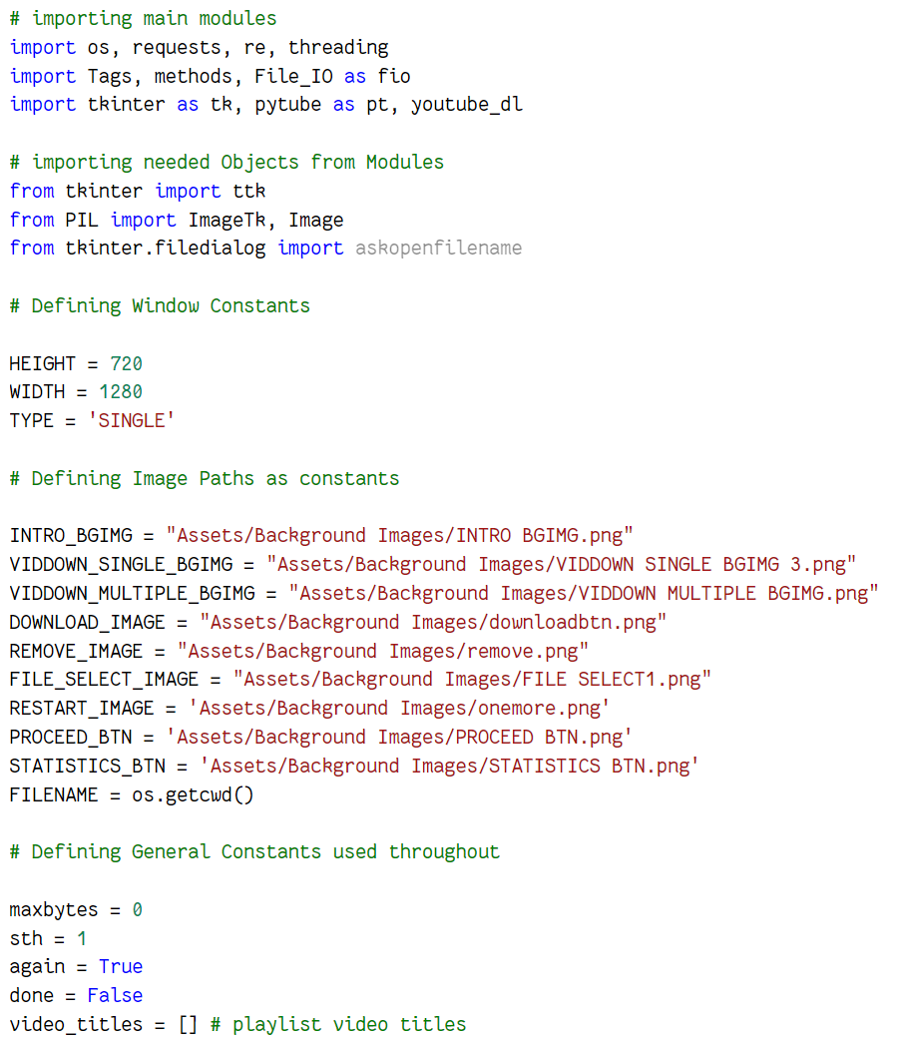Code :*

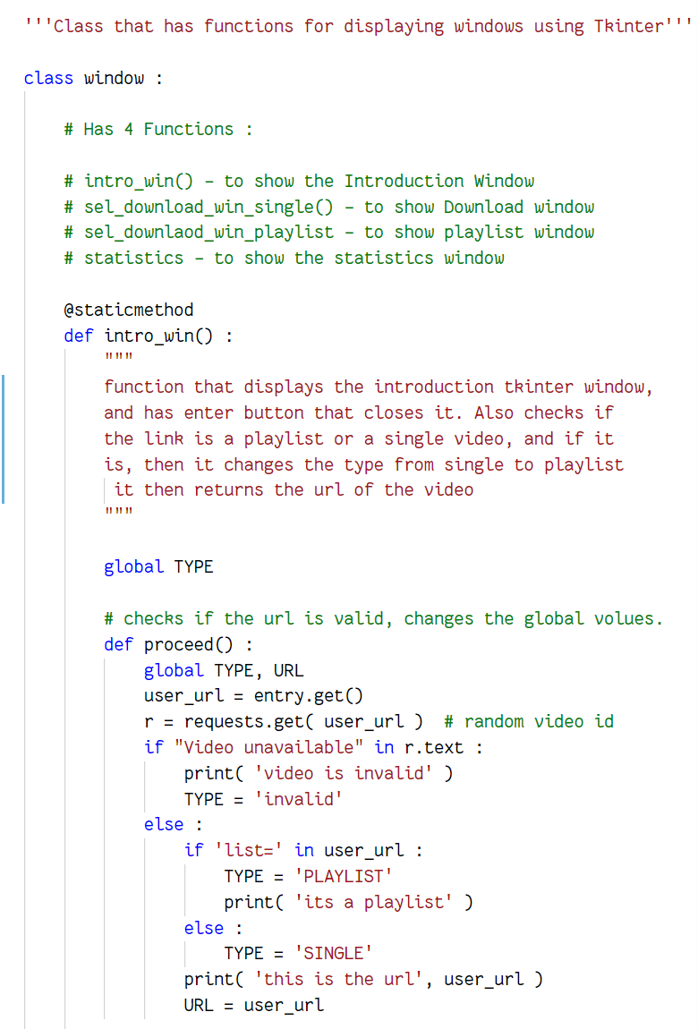

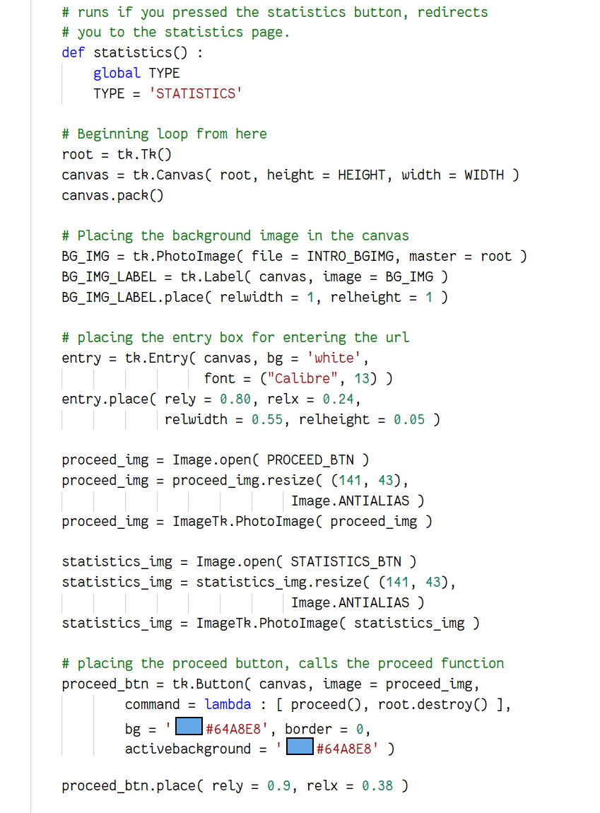

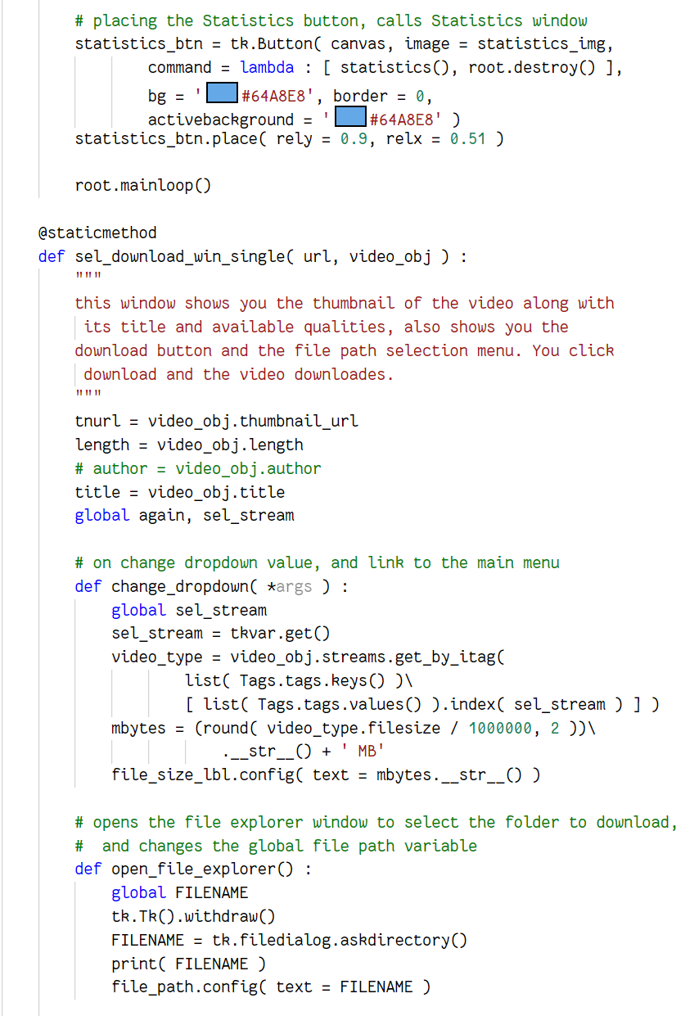

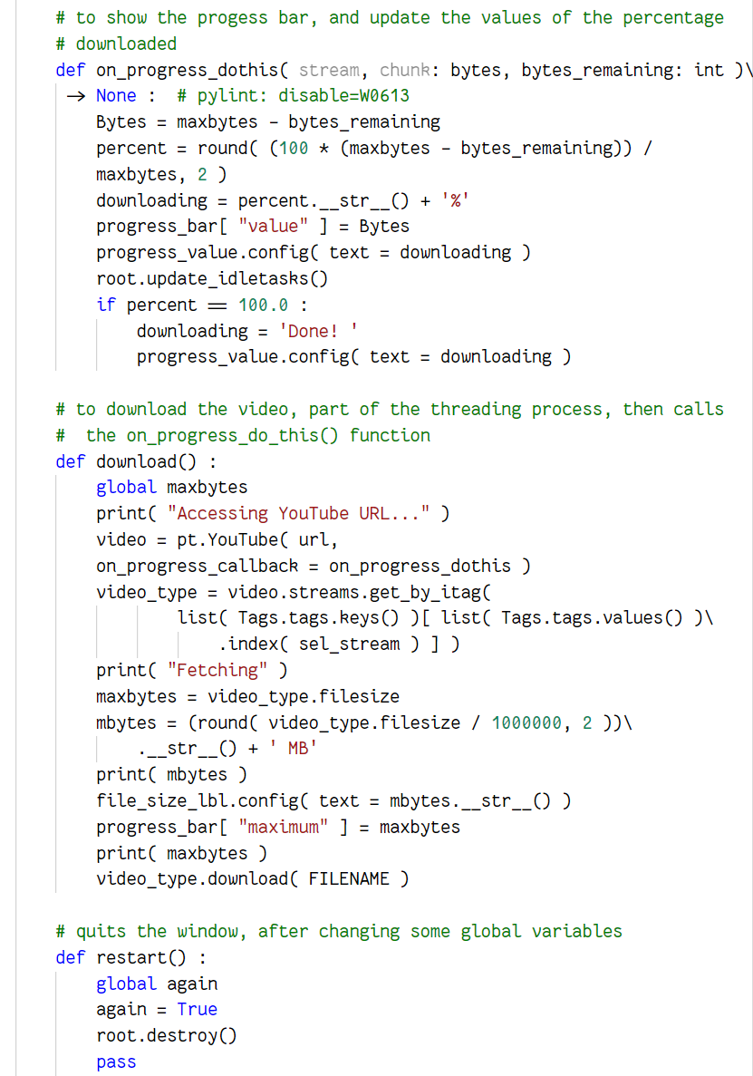

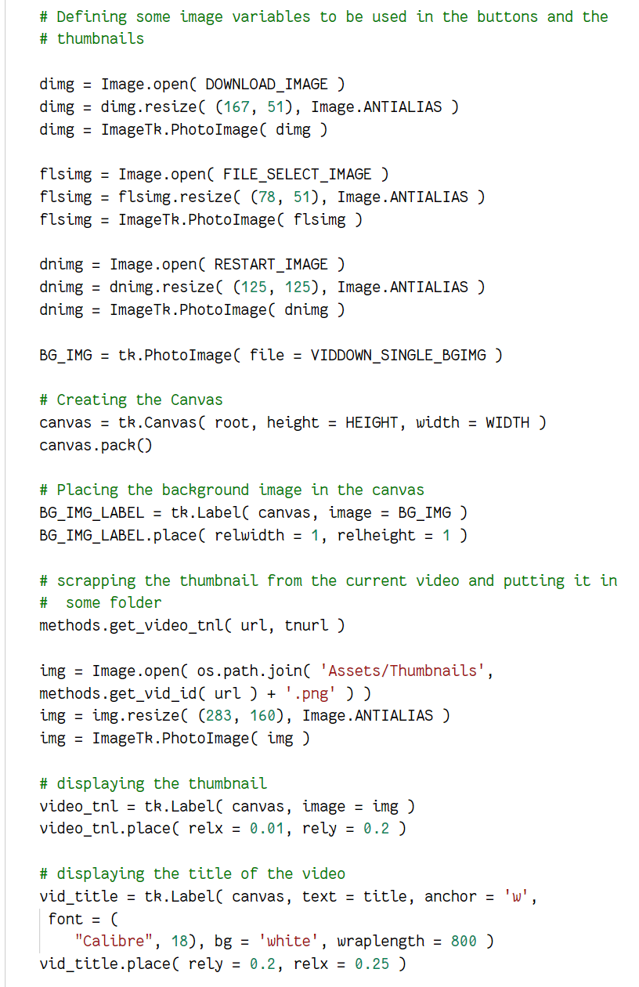

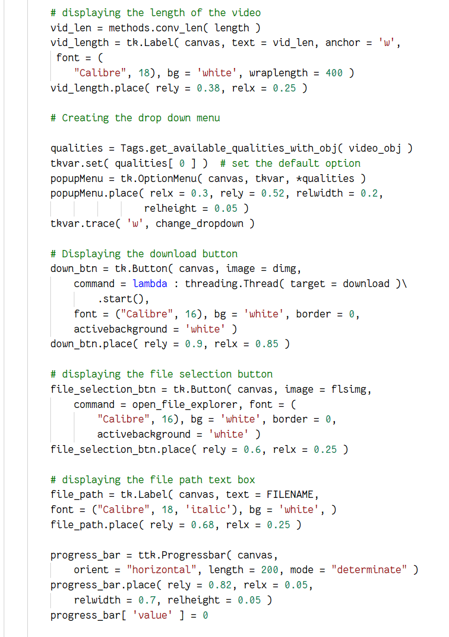

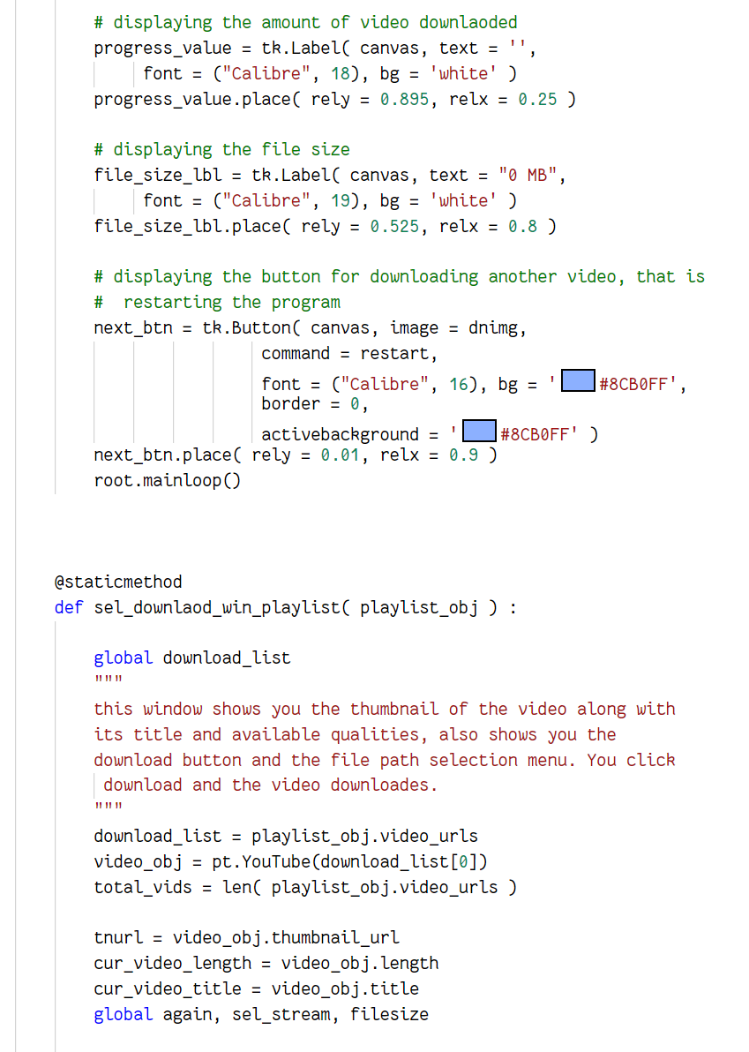

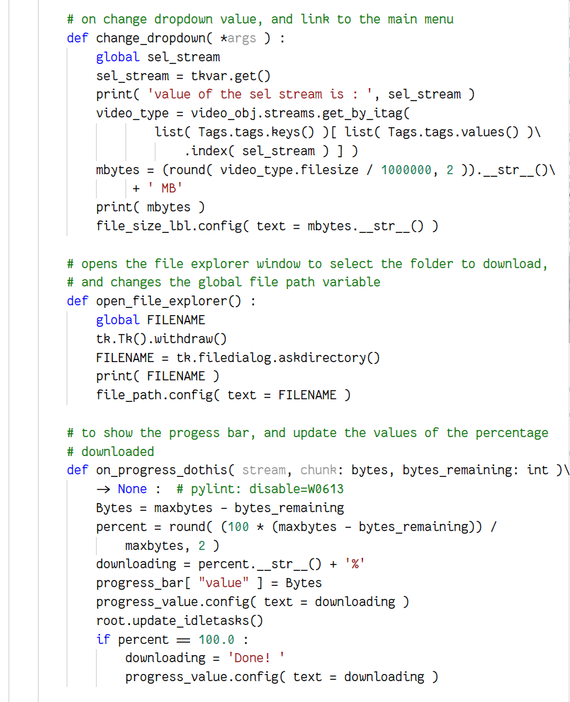

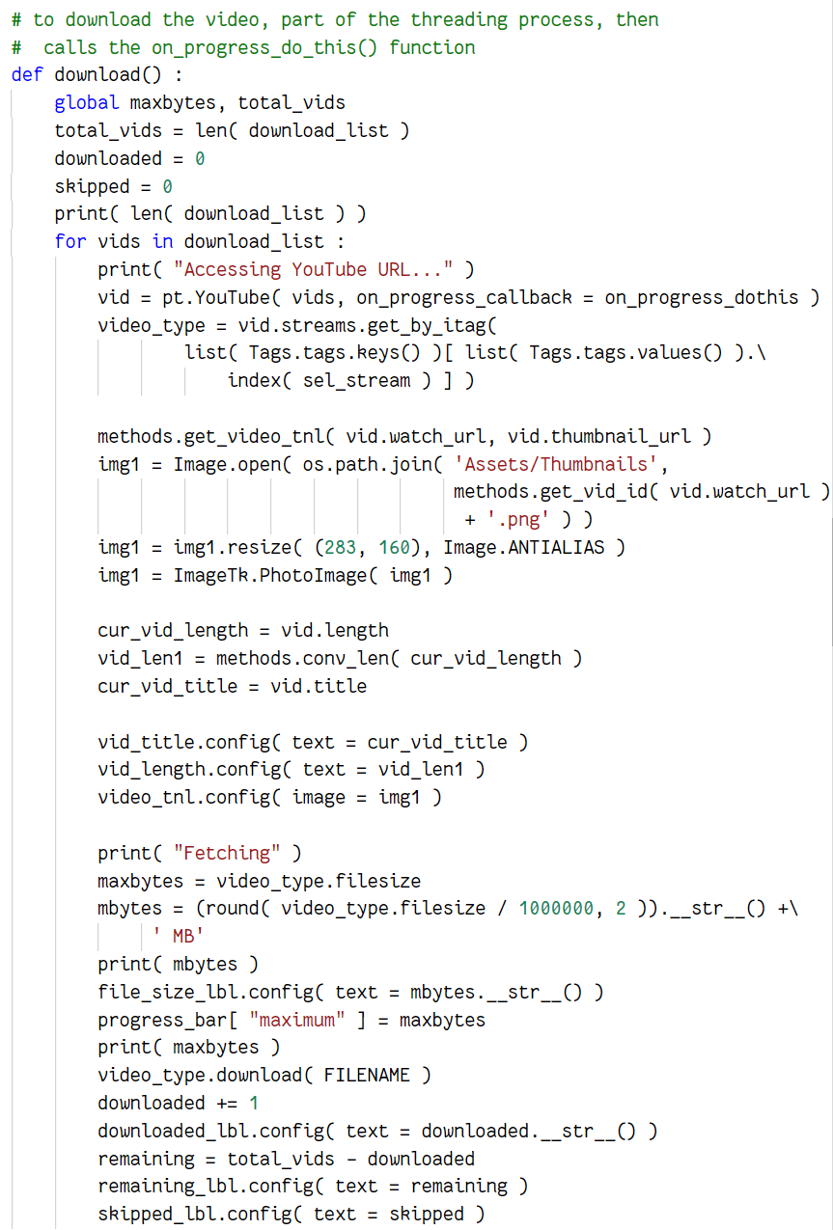

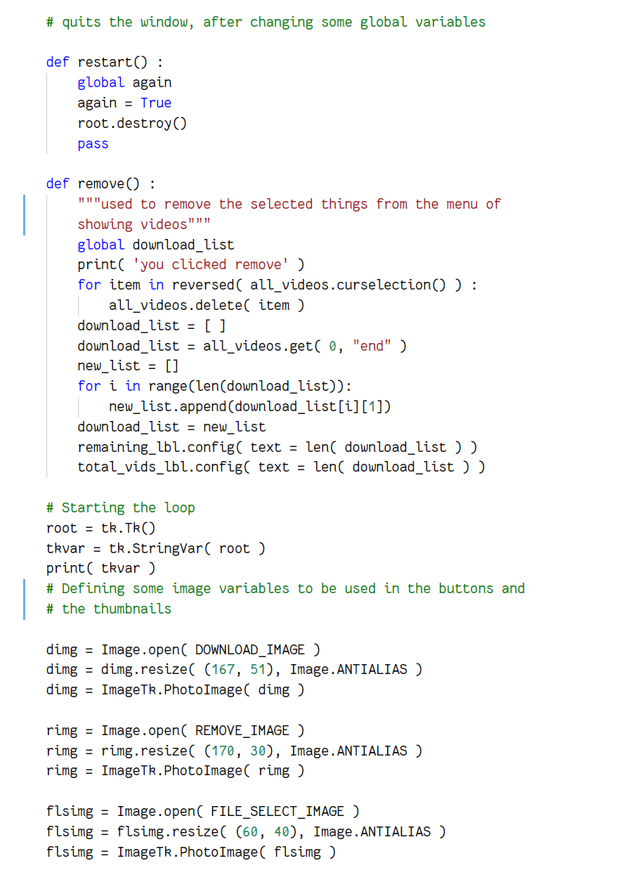

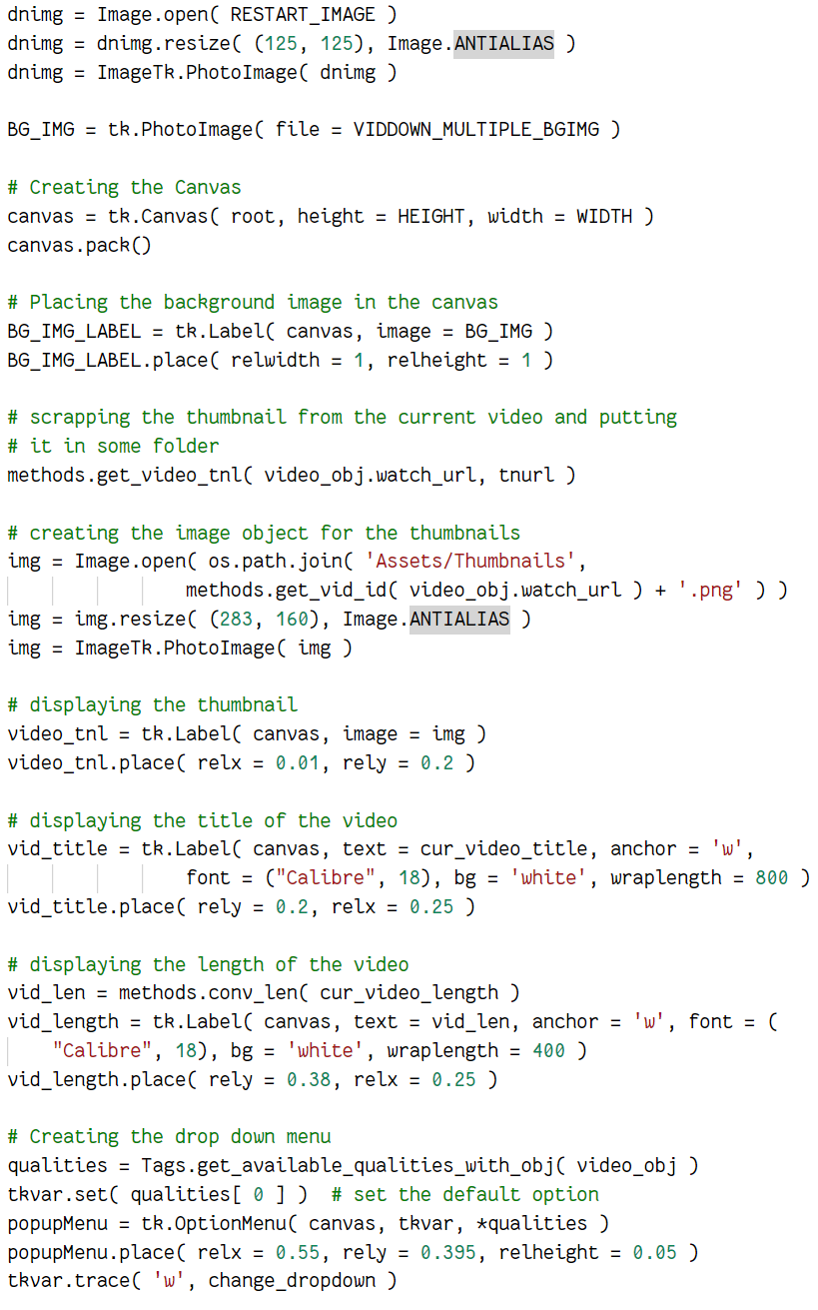

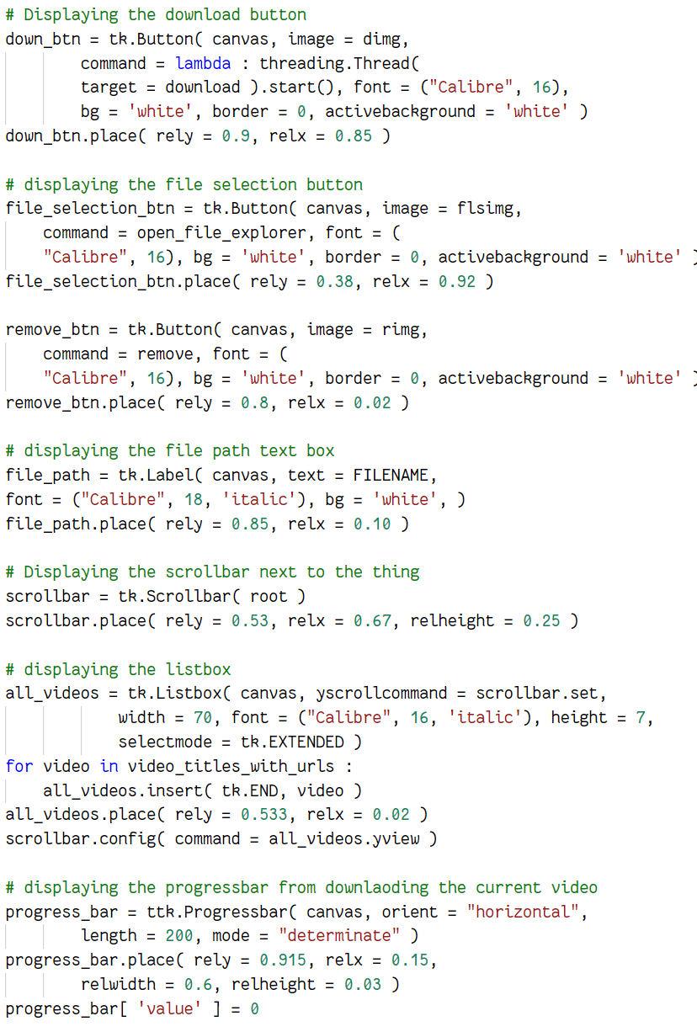

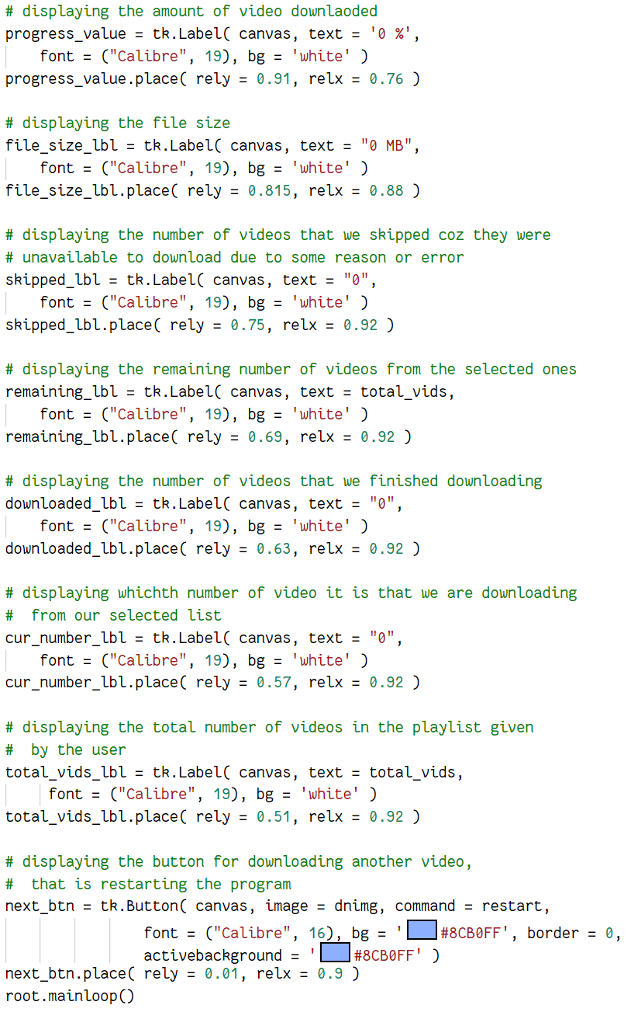

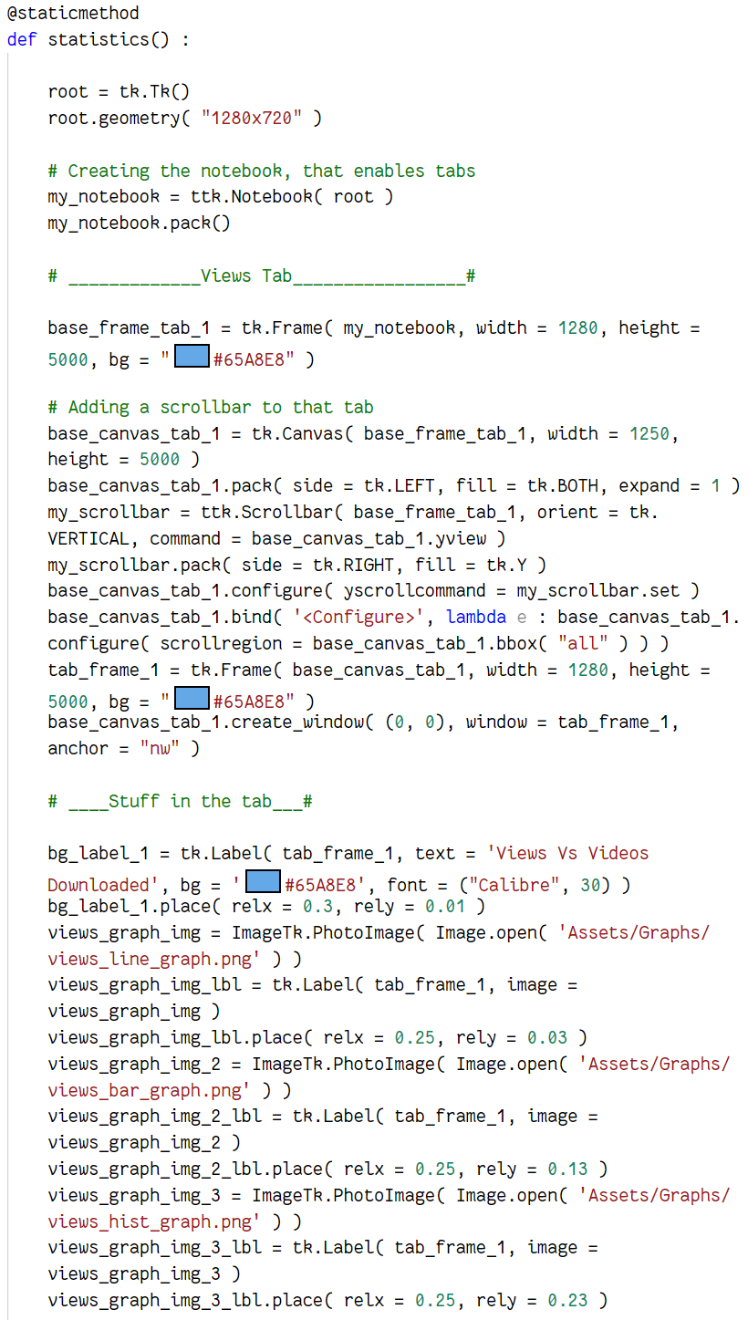















*Methods.py*





*FileIO.py*







*Graphs.py*













SCREENSHOTS OF THE PROJECT

*Main Menu Screen.*

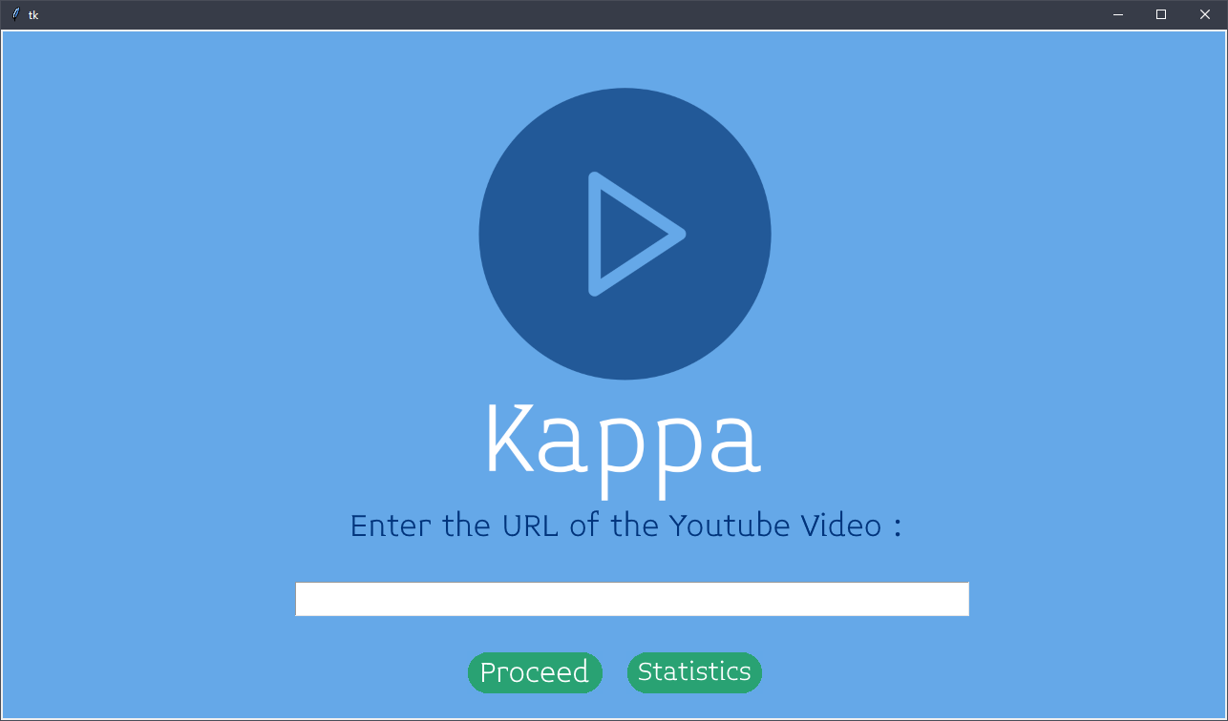

*Downloading the Video*

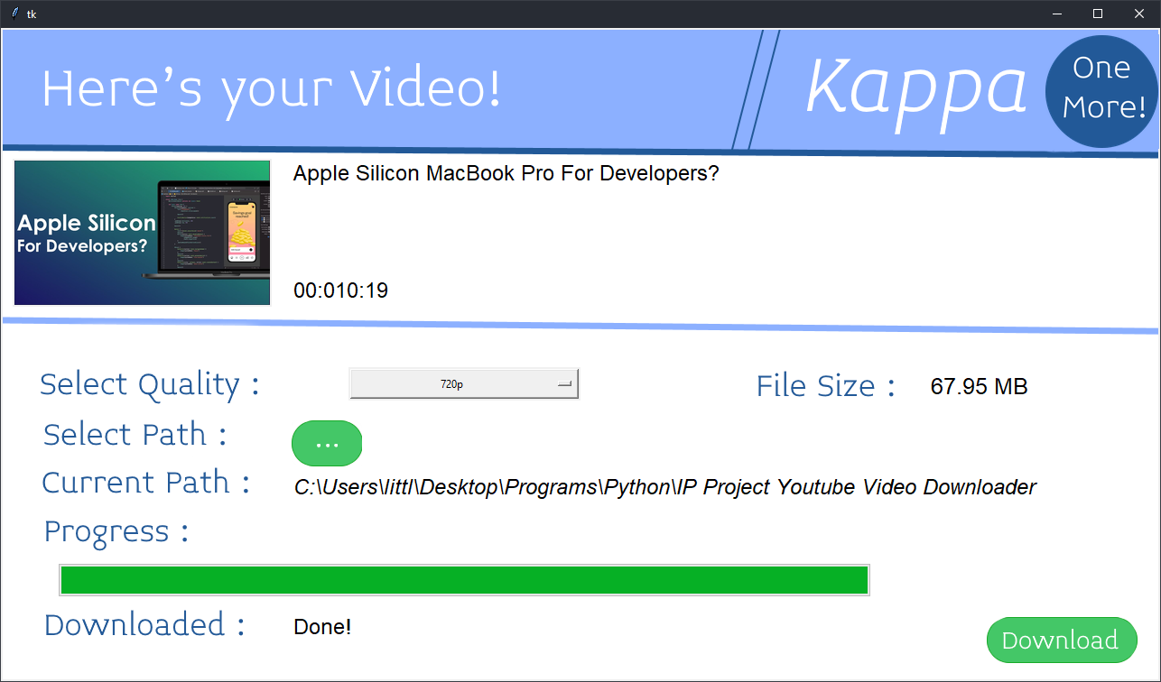

*Playlist Window*

**

*Statistics Window*

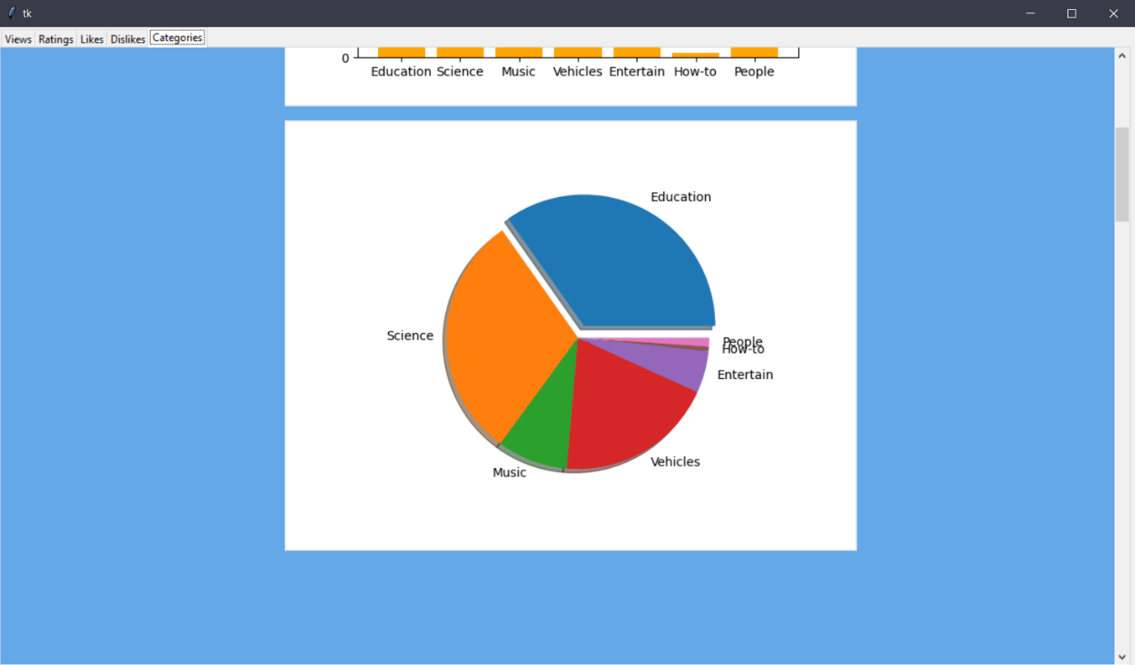

*Number of Videos vs Views*

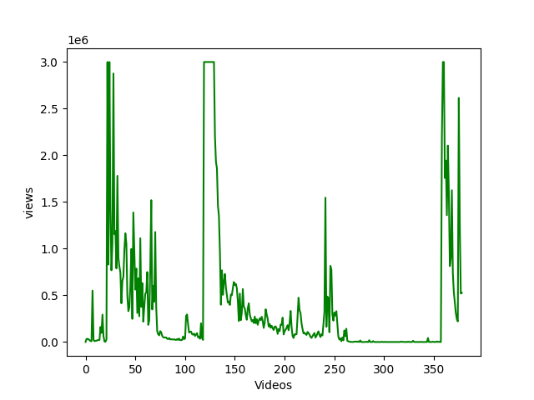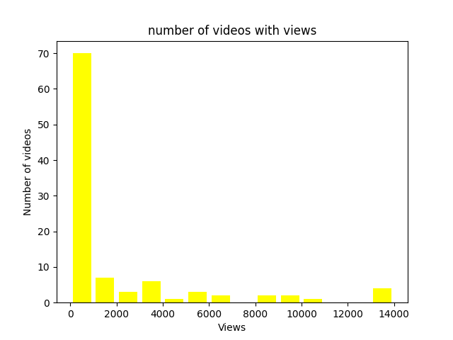

*Ratings vs Number of Videos* 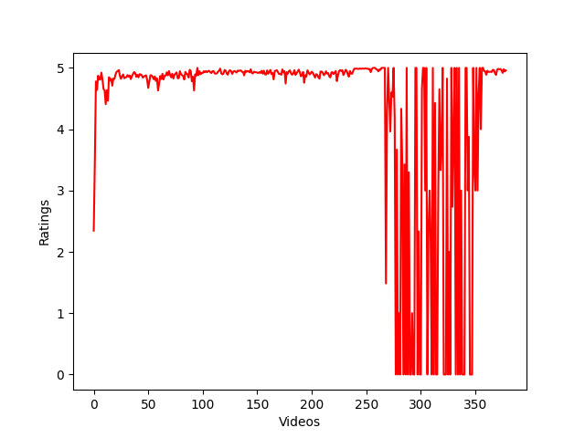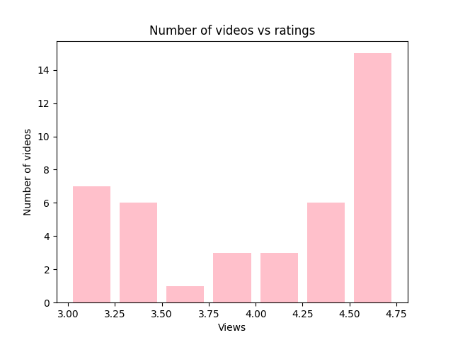

*Number of Videos vs Likes*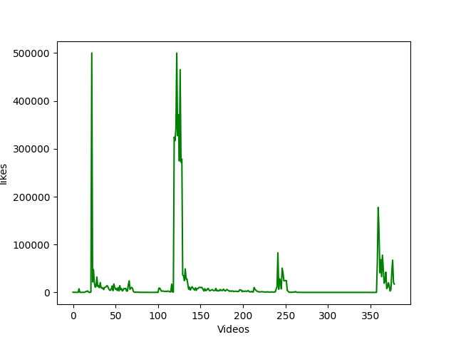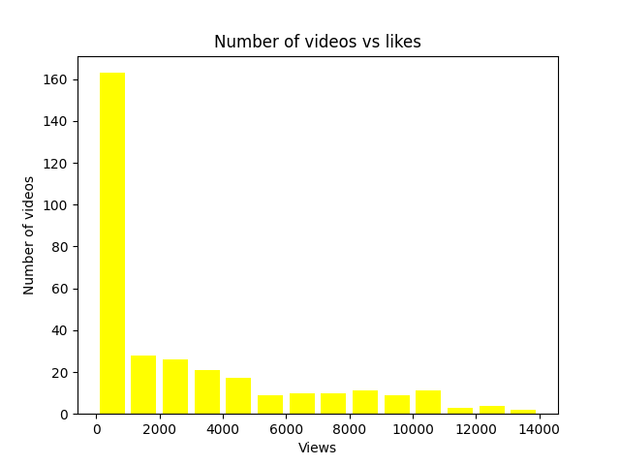

*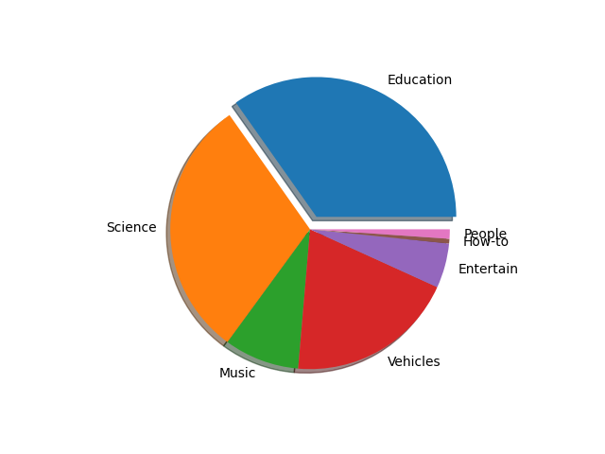Categories vs Views*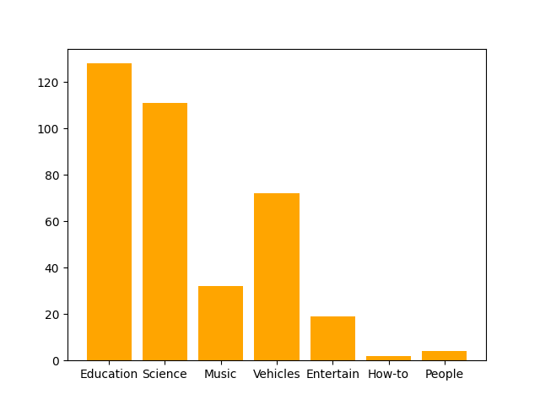

Bibliography

Thanks to Teachers, Parents, and Group members for their support and Guidance

Credits to https://youtube.com/Codemy for help on learning tkinter.

Other helpful websites:

1. <https://www.stackoverflow.com> for miscellaneous code and programming queries.

2. <https://www.github.com> for student communication

3. <https://www.namecheap.com> for logo development

Credits to the developers of modules like Pytube and youtube_dl.

Other Important and useful software used for this project :

1. ShareX for taking screenshots
2. Paint.net for editing and making the background images and doing all of the graphics and paint work in the project
3. Visual studio code and Pycharm IDE community edition for the coding.
4. Github.com for communication between students.
5. Github Desktop for uploading the code and keeping it up to date.